|  |  |
| --- | --- |
| week | Six to eight |
| class | Jss3 |
| Lesson title | User interface design |
| subtitle | introduction  GUI elements, GUI components, GUI requirement specification, GUI user analysis, gui task analysis, |
| period |  |
| duration | 40 mins |
| Learning/instructional objective | At the end of the lesson, learners should be able to:   1. Understand what user experience/interface means and how it matters 2. Understand how to approach ux and usability 3. Understand how to approach ui design |
| date |  |
| Key vocabulary |  |
| Resources and instructional materials |  |
| Previous knowledge | Students have learnt the basic concepts of computer programming, and the life cycle of softwares |

Introduction:

What is GUI elements

Graphical User Interface (GUI) elements are the visual and interactive components that make up the user interface of a software application. GUI elements enable users to interact with the application and perform various tasks. Here are some common GUI elements:

Buttons:

Buttons are interactive elements that users can click to trigger an action or perform a specific function.

Textboxes:

Textboxes allow users to input and edit text. They are commonly used for entering information such as names, addresses, or search queries.

Labels:

Labels are used to display text or provide information. They are typically non-interactive and are used to describe nearby elements.

Checkboxes:

Checkboxes allow users to make multiple selections from a list of options. Each checkbox represents an independent choice.

"GUI components" typically refers to more complex and functional entities within a user interface. These are often higher-level building blocks or self-contained units that provide specific functionality.

Examples:

Windows, dialogs, panels, tables, toolbars, file choosers, etc.

**A GUI (Graphical User Interface) requirement specification** is a document that outlines the design and functionality expectations of the graphical interface of a software application. This document is crucial for communication between stakeholders, including designers, developers, and clients, to ensure a shared understanding of how the user interface should behave and look. The GUI requirement specification typically includes the following components:

Introduction, scope, user profiles, functional requirements

**User analysis** is a crucial phase in the design and development of any product, service, or system that involves interaction with users. It involves gathering, analyzing, and understanding information about the intended users to ensure that the final product meets their needs, preferences, and expectations. The goal of user analysis is to create a user-centered design that enhances user satisfaction and usability. Here are key aspects of user analysis:

Identifying target users, user personas (fictional persons), user needs and goals, user characteristics

**GUI (Graphical User Interface) task analysis** involves breaking down the interactions and tasks that users perform within the interface of a software application. The goal is to understand how users navigate through the interface, accomplish specific tasks, and achieve their goals. Task analysis is essential for designing a user-friendly interface that supports efficient and effective user interactions. Here are the key steps in GUI task analysis:

Identify user tasks, create scenarios, break down tasks, hierarchical task analysis

What is user experience (ux)?

* Ux stands for user experience or user experience design. It is also sometime abbreviated as UXD, UED or XD
* UX is the naked experience of a product: how a product functions, not how it looks
* UX Design is the process of enhancing user satisfaction of a product through increased usability, accessbility, and pleasure provided in the interation with the product. User experience design encompasses not only traditional human-computer interaction design, but also all aspects of a product or service as perceived by users.

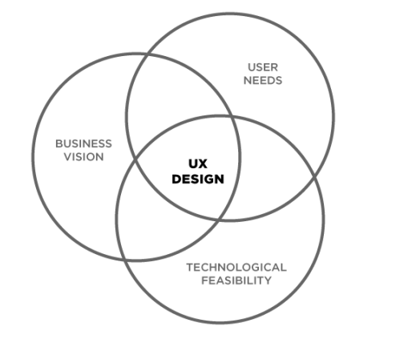

UX design is the merger of user needs, business vision and technological feasibility. The result of UX design is a set of low resolution wireframes (a basic visual guide for how a product will function) that are deeply connected with **user research.**

What is UI?

* UI stands for user interface or user interface design. It is also sometimes know as user interface engineering
* UI is the design of user interfaces for machines. How a product looks and feels, not how it functions
* UI design is the process of making the user’s interaction as simple and efficient as possible, in terms of accomplishing their goals (also known as user-centered design)

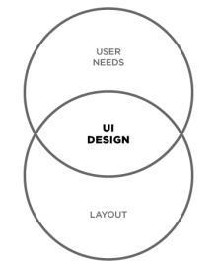

UI design is the merger of user needs and visual design. The result of UI desing is a set of high-resolution wireframes (a visual representation of a product)

Ux and ui are not the same

Ux is not ui. Ui is not ux. Let’s say our product is a home. Ux designers will create the architectureal plans for the house and decide where to build it. Ui designers will concentrate on landscaping, what color the house will be, and other visual decisions.

**What is the process of ux?**

Ux has 3 key phases: discover, ideation, and validation. However, ux design is cyclical and you will need to repeat certain steps and even the entire process multiple times.

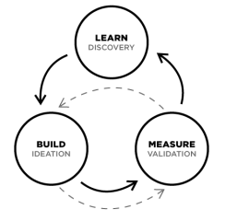

The final outcome will be a set of low-resolution wireframes: a draft of the function and structure of a product.

1. Discover: UX always starts with discovery. Interviewing potential customers to understand what the targete audience need and talking to stakeholders to understasnd their goals and competitive analysis. Discovery is all about WHY - xxx. During discovery, you will validate your problem (your product is there to solve that problem), identify your end users, and determine project goals

Methods:

* User research (interviews, ethnography
* Empathy mapping
* Task analysis
* Stakeholder mapping
* Service blueprints
* Analytics and heuristics
* Competitive analysis

Outcome: problem validation, user personas, project Goals

1. Ideate: next come ideation - using a variety of tools to imagine a solution that solves the user problem, while aligning with the company goals within technological possibility. Ideation is the process of finding out HOW. How ill you create a solution that solves the users deepest needs in a delightful manner? Designers will implement a variety of tools sto figure out how to solve the user problems. This process is very much like a funnel, where the solution is very wide at the beginning, and the goal of the process is to quickly, envision and test products with targete customers in order to pivot and define. During ideation, you will organize your discovery, explore options and develop wireframes and prototypes.

Methods:

* Sketching
* Wireframes
* Information architecture
* Journey mapping / page flows
* User journey writing
* Paper prototypes
* Interaction design

Outcome: solution exploration

1. Validate (test, prototype): the ux process ends with validation - the testing of wireframes and prototypes to iterate on the interface until it is intuitive and delightful. Validation is when we finally know WHAT we are building. During this phase, designers will create wireframes or prototypes, and test them with users during a process called usability testing to evaluate how an actual user will react to the product. The designer observes, asks open-ended questions and iterates on the wireframe based on this feedback. Validation testing is giving those wireframes or prototypes to real users.

You are tracking actual interactions with the prototype here as well as confirming previously held assumptions. The results of validation testing should be changes in flow and layout, though likely not scope anymore. During validadtion, you will validate your ideas, learn, and plan for the next iteration.

Methods:

* Accessibility
* Usability testing
* Feedback integration
* Interactive design
* Retrospectives
* Release

Outcome: solution scalability, low-res wireframes

**What is the process of UI?**

Ux has key phases: desgin and testing. UI design precedes the development of the product’s functional elements.

UI design is the creation of the finished interface; its focus is on the visual and emotional feel of the product. UI design establishes the layout, colors, typography and interactivity to visually communicate the flow of thee screens in an intuitive manner. The UI design process must balance technical functionality and visual elements to create a system that is not only operational but also usable and adaptable to changing user needs.

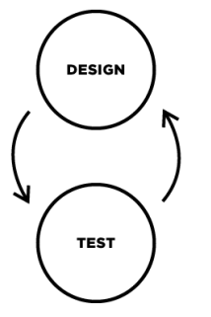

1. Design: after ideation is design - this puts your ideas to the test. During design, you will commit to internally validated ideas and test those ideas with uses. After you complete the design process, you will likeely bring what you have learned back to step 2 (ideation) and repeat this step again. This can happen multiple times

Methods:

* Design sprints
* Style guides

1. Validate (test, prototype): after you design, you willl test to validate your design ideas. During testing, you will test your ideas with uses. After you complete the testing process, you will likely bring what you have learned bact to step 1 (design) and repeat this step again. This can happen multiple times

How do UI and UX fit together

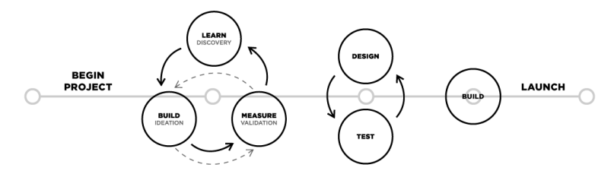

The processes of UX design and UI design are flexible and there is no “right” way of bringing them together for one project. Typically, a project will need UX design first and then UI design. However, for existing products, either process may be used alone to improve either UX or UI.

Practical Applications and Design Thinking

UX and UI are driven by Design thinking, which refers to creative strategies designers use during the process of designing. This approach is also useful to resolve issues outside of professional design practice, such as in business, social or personal contexts.

There are 5 keys to design thinking, and you can apply them to your everyday life

1. Empathize: when you design, you are not primarily doing it for yourself. You are doing it with other people’s needs and desires in mind. Focus on the person or problem that you are serving. Find ways to serve them better. Help their lovers to be better each day. Empathize first
2. Discover: try to narrow down your problem to the root cause. Jump in with an open mind, without criticism or opinions. Seek to understand before you are understood.
3. Ideate: be imaginative, create ideas to solve the problem you identified instep 2
4. Prototype: place the concept of being perfect aside. Embrace failurer to master the process. Don’t be cautious
5. Test: cultivate self-awareness by asking yourself, “what do I really want to see or experience?” Never limit yourself

Assignment

Part 1:

1. What is:
2. User research (interviews, ethnography
3. Empathy mapping
4. Task analysis
5. Stakeholder mapping
6. Service blueprints
7. Analytics and heuristics
8. Competitive analysis
9. What is:
10. Sketching
11. Wireframes
12. Information architecture
13. Journey mapping / page flows
14. User journey writing
15. Paper prototypes
16. Interaction design

Part 2: